Clery CSA Training Registration Instructions:
- Navigate to https://canvas.vt.edu/enroll/6HEPPN
- In the upper right hand corner click on “Enroll in Course”

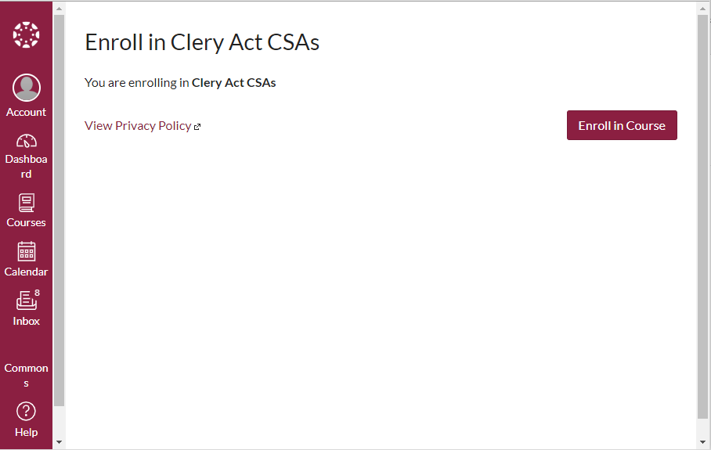
- In the upper right hand corner click on “Go to the Course”
- You are now registered in the course proceed to Clery CSA Course Instructions below

_{Clery CSA Course Instructions:}

- Watch the Clery Video by clicking on Clery Act Video in step 1
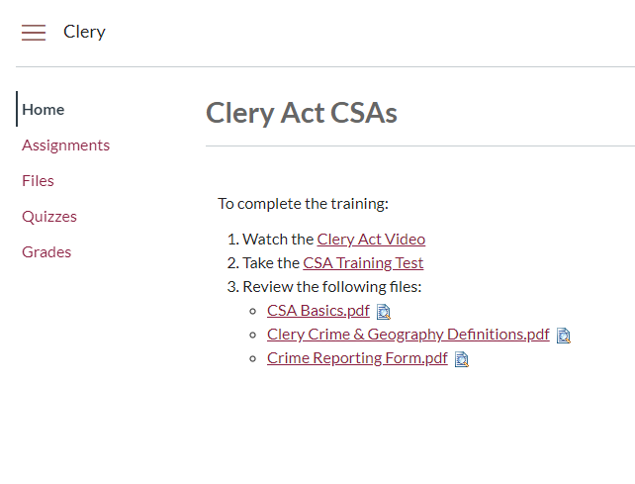
- Once you’ve watched the video, click on CSA Training Test

- In the quiz, select your answers and in the lower right hand corner click “Submit Quiz”
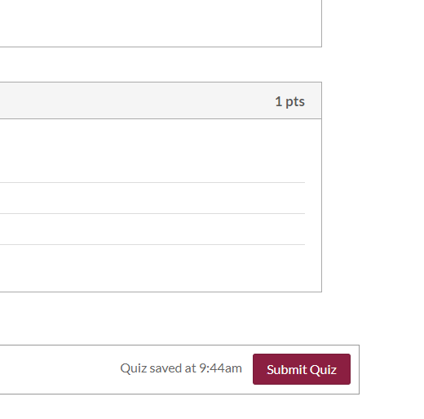
- Your results will be shown in attempt history, if you are satisfied with the result then proceed to the next step. If you would like to take the quiz again, select “Take the Quiz Again”
- Once you have finished the test, Click the Home tab
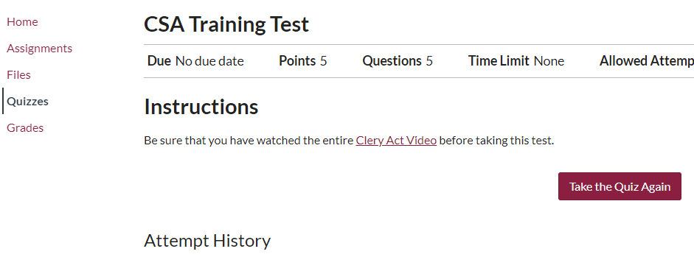
- Review the documents in step three
- After reviewing the documents, you have completed the course!

